PAISA BAZAAR BANKING FRAUD ANALYSIS
ALL-IN-ONE PROJECT DOCUMENT
Power BI Dashboard • DAX

PAGE 1  FRAUD OVERVIEW | PAGE 2  SUSPICIOUS BEHAVIOUR | PAGE 3  CUSTOMER RISK PROFILE | PAGE 4  EXECUTIVE MONITORING
1. PROJECT OBJECTIVE
The project analyzes customer credit and financial behaviour to identify risk patterns, compare customer segments, and create an executive fraud-risk monitoring dashboard. The dashboard supports prioritization and investigation; it does not prove that a customer committed fraud.
2. PROJECT REQUIREMENTS FROM THE PROVIDED DOCUMENT
The project brief requires a visually appealing and clearly organized dashboard, appropriate visualizations, meaningful insights and data storytelling, user-friendly filters and navigation, and evidence of data cleaning/transformation. It also expects the presentation to cover the project objective, dataset, business problem, data preparation, EDA flow, key visualizations, business interpretation, challenges, conclusion and future improvements.
- Visual appeal and consistent design.
- Appropriate visualization choices and clear scaling.
- Meaningful insights and a clear data story.
- Interactive filters and smooth navigation.
- Data cleaning and transformation.
- EDA progression from univariate to bivariate to multivariate analysis.
- Business interpretation and actionable observations.
- Challenges, solutions, conclusion and future improvements.
3. BUSINESS PROBLEM
The business problem is to identify customer segments with stronger credit and financial-risk signals so that management can prioritize monitoring, review payment behaviour, assess credit exposure, and focus resources on higher-risk groups.
4. DATA / ANALYTICAL CONCEPTS
- Customer-level analysis using Customer_ID.
- Credit-risk classification using Credit_Score categories such as Good, Standard and Poor.
- Financial variables such as Annual_Income, Monthly_Inhand_Salary, Outstanding_Debt, Total_EMI_per_month and Amount_invested_monthly.
- Behavioural variables such as Delay_from_due_date, Num_Credit_Inquiries and Credit_Utilization_Ratio.
- Segmentation variables such as Age Group, Occupation, Payment_Behaviour and Credit_Mix.
- Repeated customer records make DISTINCTCOUNT important for unique-customer KPIs.
5. DATA PREPARATION & TRANSFORMATION
The dashboard uses transformed fields such as Age Group and measures for customer-level and portfolio-level KPIs. The project brief also expects discussion of missing values, duplicates, inconsistencies, cleaning steps and data types during the presentation.
- Create Age Group from Age.
- Use DISTINCTCOUNT for unique customer KPIs.
- Use measures for averages and percentages.
- Use filtered measures for High Risk, Monitor and Low Risk customer counts.
- Use slicers for interactive segmentation.
- Check unknown/missing categories before drawing business conclusions.
6. COMPLETE DAX MEASURES CREATED
Total Customers
Total Customers =
DISTINCTCOUNT(CreditData[Customer_ID])
High Risk Customers
High Risk Customers =
CALCULATE(
DISTINCTCOUNT(CreditData[Customer_ID]),
CreditData[Credit_Score] = "Poor"
)
High Risk %
High Risk % =
DIVIDE(
[High Risk Customers],
[Total Customers],
0
)
Average Credit Utilization %
Average Credit Utilization % =
AVERAGE(CreditData[Credit_Utilization_Ratio])
Average Delayed Payments
Average Delayed Payments =
AVERAGE(CreditData[Delay_from_due_date])
Average Credit Inquiries
Average Credit Inquiries =
AVERAGE(CreditData[Num_Credit_Inquiries])
Average Outstanding Debt
Average Outstanding Debt =
AVERAGE(CreditData[Outstanding_Debt])
Average Bank Accounts
Average Bank Accounts =
AVERAGE(CreditData[Num_Bank_Accounts])
Average Credit Cards
Average Credit Cards =
AVERAGE(CreditData[Num_Credit_Card])
Average Loans
Average Loans =
AVERAGE(CreditData[Num_of_Loan])
Average Annual Income
Average Annual Income =
AVERAGE(CreditData[Annual_Income])
Average Monthly Salary
Average Monthly Salary =
AVERAGE(CreditData[Monthly_Inhand_Salary])
Average EMI
Average EMI =
AVERAGE(CreditData[Total_EMI_per_month])
Average Investment
Average Investment =
AVERAGE(CreditData[Amount_invested_monthly])
Customers to Monitor
Customers to Monitor =
CALCULATE(
DISTINCTCOUNT(CreditData[Customer_ID]),
CreditData[Credit_Score] = "Standard"
)
Low Risk Customers
Low Risk Customers =
CALCULATE(
DISTINCTCOUNT(CreditData[Customer_ID]),
CreditData[Credit_Score] = "Good"
)
Overall Fraud Risk Score
Overall Fraud Risk Score =
ROUND(
([High Risk %] * 100) * 0.50 +
MIN([Average Delayed Payments] / 30 * 100, 100) * 0.25 +
MIN([Average Credit Inquiries] / 15 * 100, 100) * 0.25,
0
)
Risk Score Target
Risk Score Target =
70
Risk Category
Risk Category =
SWITCH(
TRUE(),
[Overall Fraud Risk Score] >= 70, "HIGH RISK",
[Overall Fraud Risk Score] >= 40, "MEDIUM RISK",
"LOW RISK"
)
7. CALCULATED COLUMN: AGE GROUP
Age Group =
SWITCH(
TRUE(),
CreditData[Age] >= 18 && CreditData[Age] <= 25, "18-25",
CreditData[Age] >= 26 && CreditData[Age] <= 35, "26-35",
CreditData[Age] >= 36 && CreditData[Age] <= 45, "36-45",
CreditData[Age] >= 46 && CreditData[Age] <= 55, "46-55",
CreditData[Age] >= 56, "55+",
"Unknown"
)
Age Group is a calculated column because Age is a row-level attribute. It allows the dashboard to compare meaningful age bands instead of individual ages.
8. WHY THESE DAX FUNCTIONS WERE USED
Function | Used For | Interview Explanation
DISTINCTCOUNT | Unique customers | The source contains repeated customer records, so I needed unique customer counts.
CALCULATE | Filtered customer counts | It modifies filter context, for example to isolate Poor credit-score customers.
DIVIDE | Percentages | It safely calculates ratios and handles division-by-zero.
AVERAGE | Financial/behavioural KPIs | It represents the typical customer level rather than the total.
SWITCH(TRUE()) | Age and risk bands | It evaluates multiple logical conditions in sequence.
MIN | Risk-score normalization | It caps normalized components at 100.
ROUND | Executive risk score | It presents the composite score as a clean executive number.
9. PAGE 1 – FRAUD OVERVIEW
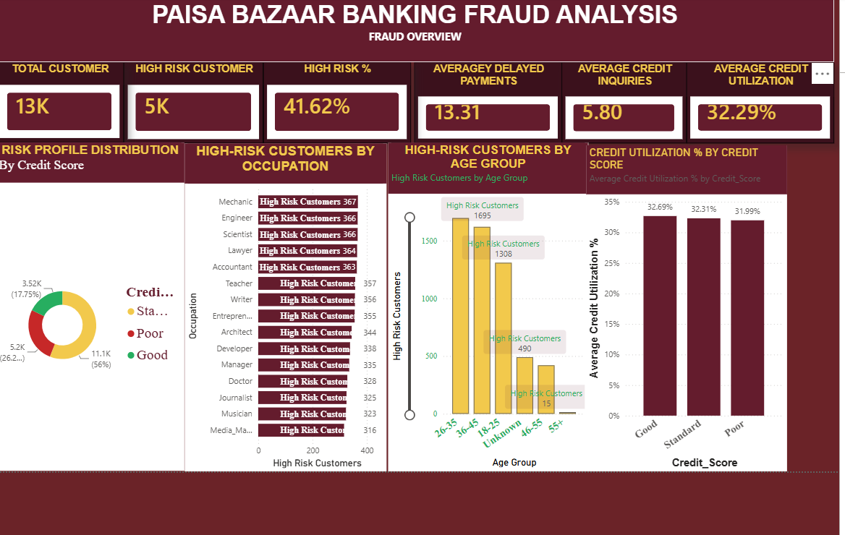
Story: First establish the overall risk landscape and identify where high-risk customers are concentrated.
KPI cards:
- Total Customer
- High Risk Customer
- High Risk %
- Average Delayed Payments
- Average Credit Inquiries
- Average Credit Utilization
Charts:
- Risk Profile Distribution by Credit Score
- High-Risk Customers by Occupation
- High-Risk Customers by Age Group
- Credit Utilization % by Credit Score
Main insights:
- Approximately 13K unique customers are represented on the overview.
- The dashboard shows approximately 5K high-risk customers and 41.62% High Risk.
- Risk concentration differs by occupation and age group.
- Credit utilization is a recurring financial-risk indicator.
10. PAGE 2 – SUSPICIOUS BEHAVIOUR ANALYSIS
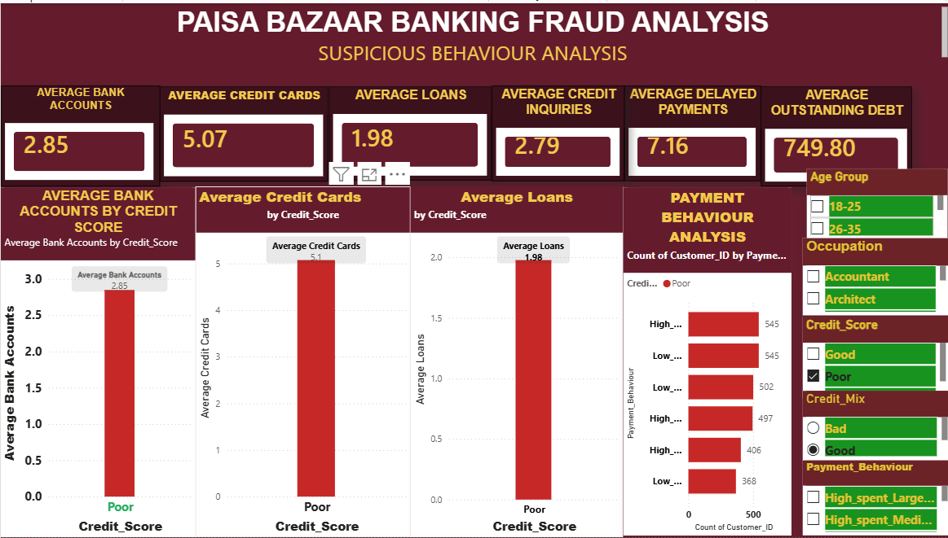
Story: Move from who is at risk to how customers behave financially.
KPI cards:
- Average Bank Accounts
- Average Credit Cards
- Average Loans
- Average Credit Inquiries
- Average Delayed Payments
- Average Outstanding Debt
Charts:
- Average Bank Accounts by Credit Score
- Average Credit Cards by Credit Score
- Average Loans by Credit Score
- Payment Behaviour Analysis
Main insights:
- Financial product exposure can be compared across credit-score groups.
- Delayed payments and credit inquiries provide additional behavioural signals.
- Payment behaviour can be filtered by Age Group, Occupation, Credit Score, Credit Mix and Payment Behaviour.
11. PAGE 3 – CUSTOMER FRAUD-RISK PROFILE
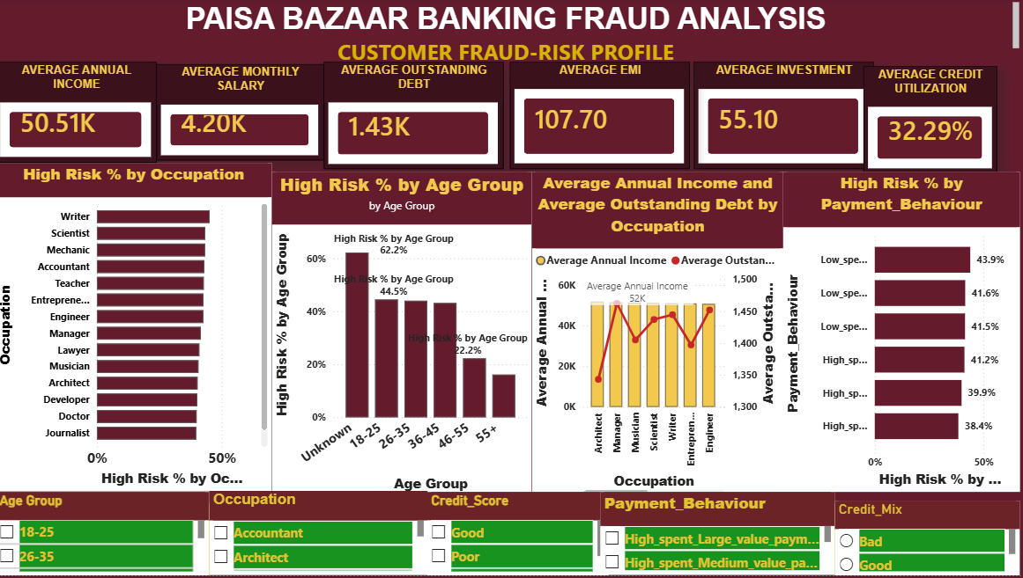
Story: Build the financial profile behind customer risk.
KPI cards:
- Average Annual Income
- Average Monthly Salary
- Average Outstanding Debt
- Average EMI
- Average Investment
- Average Credit Utilization
Charts:
- High Risk % by Occupation
- High Risk % by Age Group
- Average Annual Income and Average Outstanding Debt by Occupation
- High Risk % by Payment Behaviour
Observed age-group pattern:
- Unknown ≈ 62.2%
- 18–25 ≈ 44.5%
- 26–35 ≈ 44.0%
- 36–45 ≈ 43.1%
- 46–55 ≈ 22.2%
- 55+ ≈ 16.1%
Interpretation: the dashboard shows higher observed high-risk percentages in the younger identified age groups than in the older groups. The high Unknown percentage also signals a data-quality issue that should be investigated. This is an association in the dataset, not evidence that age causes fraud.
12. PAGE 4 – FRAUD RISK MONITORING / EXECUTIVE VIEW
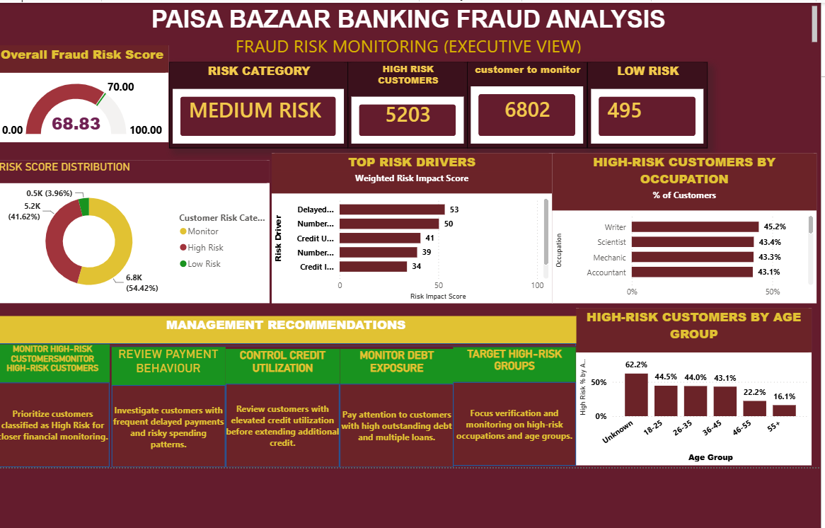
Story: Convert the detailed analysis into an executive monitoring view.
KPI cards:
- Overall Fraud Risk Score
- Risk Category
- High Risk Customers
- Customers to Monitor
- Low Risk Customers
Visuals:
- Overall Fraud Risk Score Gauge
- Risk Score Distribution
- Top Risk Drivers
- High-Risk Customers by Occupation
- High-Risk Customers by Age Group
- Management Recommendations
Current executive distribution:
Risk Category | Customers | Share
High Risk | 5,203 | 41.62%
Monitor | 6,802 | 54.42%
Low Risk | 495 | 3.96%
The dashboard shows an overall analytical risk score around 69, close to the 70 high-risk threshold. Under the project's defined thresholds, this is Medium Risk.
13. TOP RISK DRIVER INSIGHTS
- Delayed payments are one of the strongest visible risk drivers.
- Number of loans contributes to the overall risk-driver view.
- Credit utilization is a recurring exposure indicator.
- Number of credit cards and credit inquiries add further context to customer risk.
- Risk drivers should be interpreted together rather than as proof of fraud from one variable.
14. MANAGEMENT RECOMMENDATIONS
- Monitor high-risk customers with multiple simultaneous risk indicators.
- Review customers with repeated delayed payments and risky spending patterns.
- Review elevated credit utilization before extending additional credit.
- Pay attention to customers with high outstanding debt and multiple loans.
- Focus verification and monitoring on high-risk occupations and age groups.
15. COMPLETE BUSINESS INSIGHTS
- 41.62% of customers are classified as high risk under the dashboard definition.
- The Monitor category is the largest group at 54.42%.
- The Low Risk group is comparatively small at 3.96%.
- Delayed payments and credit utilization are important monitoring indicators.
- Credit inquiries add a credit-seeking behaviour signal.
- Observed high-risk percentages vary substantially across age groups.
- Observed high-risk percentages vary across occupations.
- Income, salary, debt, EMI and investment provide financial context around customer risk.
- The executive score is close to the high-risk threshold, so targeted monitoring is appropriate.
- The dashboard is a risk-monitoring tool, not a fraud-confirmation system.
16. EDA STORY: UNIVARIATE → BIVARIATE → MULTIVARIATE
- Univariate: understand individual variables such as Age, Income, Debt, Credit Score and Payment Behaviour.
- Bivariate: compare risk against Occupation, Age Group, Credit Score and Payment Behaviour.
- Multivariate: connect income, debt, utilization, payment behaviour, occupation and age in the risk profile.
- Executive synthesis: convert the strongest signals into Page 4 risk monitoring.
This sequence follows the project brief's requirement to explain how each analytical stage helped uncover deeper insights.
17. FILTERS & NAVIGATION
- Age Group
- Occupation
- Credit Score
- Payment Behaviour
- Credit Mix
- Page Navigator for Fraud Overview, Suspicious Behaviour, Customer Fraud-Risk Profile and Fraud Risk Monitoring.
- In Power BI Desktop editing mode, Ctrl + Click a navigator button to test navigation.
18. PRESENTATION SCRIPT
Opening: This is a banking customer risk-analysis project built in Power BI. The objective is to identify customer segments with stronger financial and behavioural risk signals and provide management with an interactive monitoring dashboard.
Problem: The main business question is where risk is concentrated, what behaviours are associated with the risk, and which customer segments should receive closer monitoring.
Page 1: Page 1 establishes the risk landscape. I use unique customer counts, high-risk counts and percentages, then analyze occupation, age group and credit utilization.
Page 2: Page 2 investigates suspicious financial behaviour by comparing bank accounts, credit cards, loans and payment behaviour across credit-score groups.
Page 3: Page 3 builds a deeper customer profile using income, salary, debt, EMI, investment and credit utilization, then connects those variables with occupation, age and payment behaviour.
Page 4: Page 4 is the executive monitoring view. It summarizes the analytical risk score, risk category, customer distribution, top risk drivers and recommended management actions.
Conclusion: The analysis indicates a substantial high-risk and monitor population. Delayed payments, utilization and credit-seeking behaviour are important indicators, while age and occupation show different observed risk concentrations. The dashboard therefore supports targeted monitoring rather than a one-size-fits-all approach.
19. CHALLENGES & HOW THEY WERE HANDLED
- Repeated customer records: handled with DISTINCTCOUNT for unique-customer KPIs.
- Single-value Age error: solved by creating Age Group as a calculated column instead of incorrectly using raw Age in a measure.
- Risk percentages: handled with DIVIDE and filtered measures.
- Dashboard repetition: Page 2 was kept to four main charts to avoid duplicating the same analysis.
- Navigation: Page Navigator was added for all four pages.
- Executive gauge target: a target of 70 was defined for the custom risk-score scale.
- Unknown age category: retained as an explicit category so the data-quality signal remains visible.
20. INTERVIEW QUESTIONS & SHORT ANSWERS
Why did you use DISTINCTCOUNT?
Because the same customer can appear in multiple records, so COUNT would overstate unique customers.
Why did you use CALCULATE?
To modify filter context and calculate customer counts for specific risk categories.
Why use DIVIDE?
It safely handles division-by-zero when calculating percentages.
Why use AVERAGE?
To show the typical customer level for financial and behavioural measures.
Why create Age Group?
To make age analysis easier to interpret and visualize.
Why these charts?
They directly answer the business questions and progress from distribution to comparison and deeper profiling.
What is the most actionable insight?
A large Monitor and High Risk population means risk-based monitoring should be prioritized, with attention to delayed payments and credit exposure.
Is the risk score official fraud probability?
No. It is a custom analytical index created for this project.
What would you do next?
Add predictive modelling, investigate missing/unknown data, validate risk drivers, and build more advanced monitoring or alerting.
21. CONCLUSION & FUTURE IMPROVEMENTS
The completed dashboard creates a logical four-page story: identify the risk landscape, investigate behaviour, profile customers, and monitor risk at executive level.
- Future improvement: predictive modelling for probability of high-risk classification.
- Future improvement: customer-level risk scoring with a clearly defined latest-period rule.
- Future improvement: deeper missing-data and anomaly analysis.
- Future improvement: automated alerts for significant risk changes.
- Future improvement: trend analysis over time.
- Future improvement: validate the custom risk score against a labelled fraud outcome if such a label becomes available.
22. FINAL ONE-MINUTE SUMMARY
“My Paisa Bazaar Banking Fraud Analysis project uses Power BI and DAX to analyze customer credit and financial behaviour. I first identified the overall risk population, then investigated financial and payment behaviour, followed by a deeper customer profile using income, debt, EMI, investment, occupation and age. Finally, I created an executive risk-monitoring page with a custom analytical risk score, risk distribution, risk drivers and management recommendations. The dashboard shows 41.62% high-risk customers and 54.42% in the monitor category. The key message is that risk should be prioritized using multiple financial and behavioural indicators rather than a single variable.”
23. SOURCE / PROJECT-BRIEF ALIGNMENT
The supplied project brief requires visual appeal, appropriate visualization, meaningful insights, interactivity, data preparation, a clear EDA sequence, key visualization explanations, business interpretation, challenges, conclusion and future improvements. This consolidated document organizes the completed dashboard work around those requested sections.

SCREENSHOT REFERENCE
Screenshot 1: FRAUD OVERVIEW
Screenshot 2: SUSPICIOUS BEHAVIOUR ANALYSIS
Screenshot 3: CUSTOMER FRAUD-RISK PROFILE
Screenshot 4: FRAUD RISK MONITORING / EXECUTIVE VIEW

